Create a Jenkins “Freestyle Project” and name the project

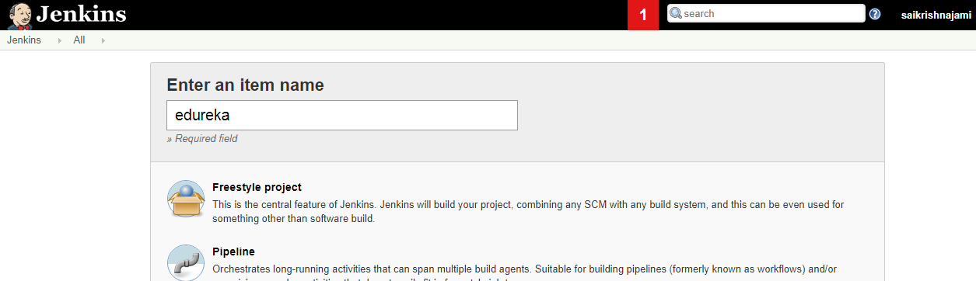

Enable “Git” in Source Code Management and Provide the repository url as :

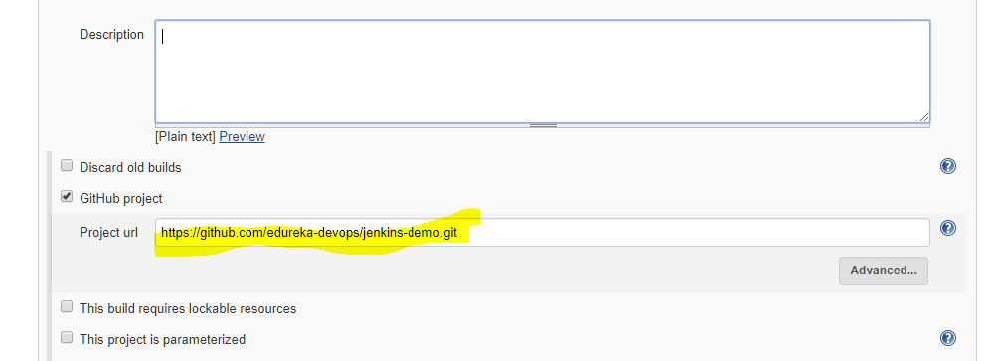

Enable Poll SCM and update the schedule in it.

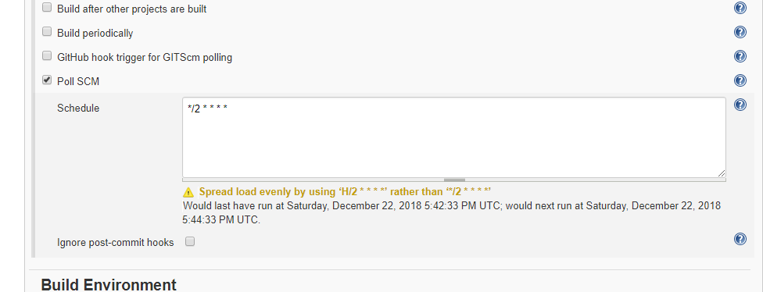

Enable the Build Environment to “Delete workspace before build starts” and “Abort the build if it's stuck”

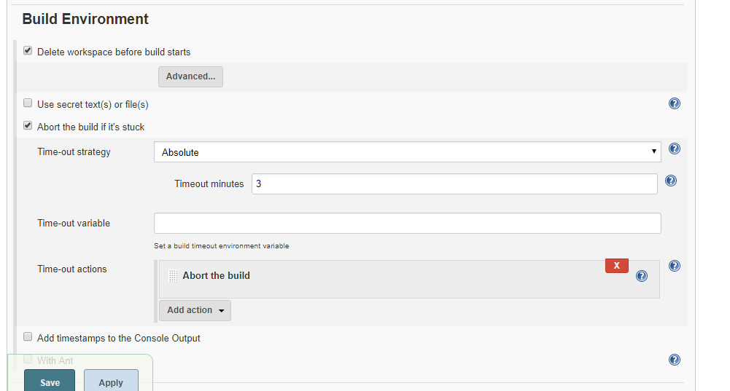

In Build select “Execute shell”, give permisson to the shell script to be executed, add the shell script to be executed and redirect the output of the shell script to a file in workspace.

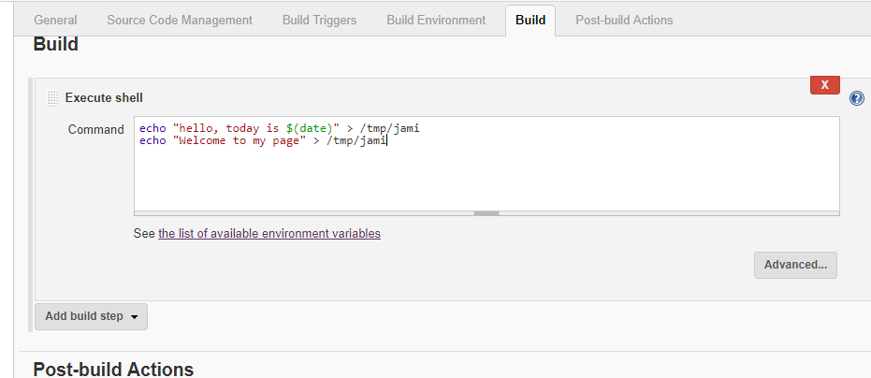

Apply and save the job

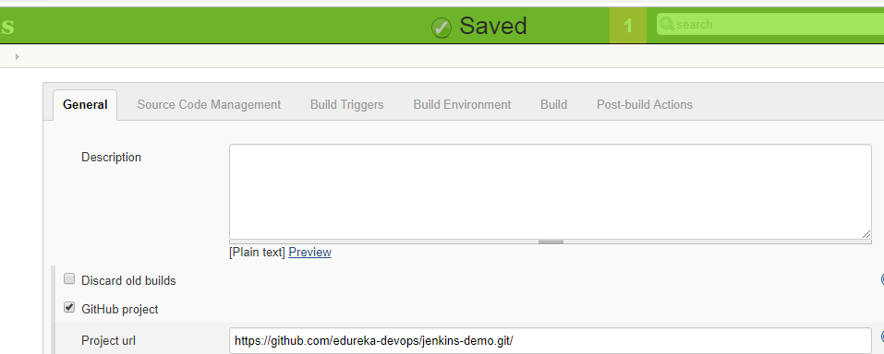

Upon triggering the job, the execution has to be success and the output file containing the shell script output should be present in Workspace

